Perceptions of Expression: A Replication of Lott et al. 2022

Kiera Wingo

PSYC 4431

December 2022

Dr. Matthew Robison

**Perceptions of Expression: A Replication of Lott et al. 2022**

Emotion expression, that is nonverbal communication, is critical to human communication. Expression is largely important for social interactions as it can indicate an individual’s approachability, physical or emotional state, or their interest in a social interaction (Tracy et al., 2015). The study of non-verbal communication through emotions dates back to Charles Darwin when he claimed it evolved from emotionless non-verbal cues. Supporting this idea roughly a century later, isolated indigenous peoples from South America displayed accurate perception and recognition of facial expression in the same manner as western American’s leading to the theory that emotional may have a universal aspect. Modern day research widely accepts that there are six emotions perceived identically universally including happiness, anger, disgust, sadness, fear, and surprise, all of which can be displayed through facial or bodily expression (Ekman, 1992).

Literature pertaining to facial expressions has been studied for quite some time while literature pertaining to body expression has been lacking until more recently. The importance of research on body expression specifically stems from modern facial inhibitors like masks and botulinum toxin, which inhibit all or portion of facial expressions (Nestor et al. 2020). This notion lends to support in favor of literature focused on body expression as negative emotions can be more readily perceived, expressions body can be interpreted at a distance, inhibitions of the face do not need to be a concern, and body expression amplifies that of the face (Abramson et al. 2021).

Cognitive perceptions of human expressions are difficult to study. Confounds plaque data and research due to the variety of testing methods, difficulty in synthesizing biased free stimuli, and importantly individual differences in perceptions. As such, the study by Lott et al. set out to produce a standardized set of emotionally expressive stimuli from which to gauge emotion perception of the face and body. Using computer models, the researchers firstly created the EMface stimulus set via artificial intelligence (AI) by generating unique faces and animating them to express either anger, happiness, or no emotion (neutral). The complementing body stimuli, EMbody, was created via computer-animated dynamic point-light display and represents 15 majors points of the body. Additional measures of intelligence, self-reported autistic traits, vocabulary, depressive symptoms, and a reading in the mind’s eye task were employed by the original study to ensure participants did not have an infliction which inhibited their general perception of emotion. The results concluded that the EMface and EMbody stimuli sets were successful in displaying standardized, precise, and simple to use measures for gauging emotion perception.

The following study is not an exact replica of the original due to constrains with sample size and access to materials. The hypotheses for the replica experiment were 1) emotion will not be perceived equally accurately and 2) facial expressions will be perceived quicker than body expressions.

**Methods**

*Participants*

A total of 8 participants were included in the study. There were no exclusion criteria for participants meaning parameters of age, ethnicity, or socio-economic status were not factored into participant selection. The participants were recruited from psychology students at the University of Texas at Arlington and by word of mouth forming a connivence sample. Informed consent was not given to the participants. The study was non-compensated, mandatory for the students, and voluntary for those recruited by word of mouth.

*Materials*

The study was completed online using the host system Pavlovia and taken on participant’s personal devices. The experiment included 84 opensource videos from the EMbody/EMface stimuli set created by Lott et al. 2022, an example of which is shown in Figure 1. The stimulus was created by artificial intelligence (AI) to generate and animate unique faces and body animations comprised of dots indicating 15 major points of the body (head, major joints, extremities). The experiment was created using PsychoPy v2022.2.4 and the resulting data gathered from Pavlovia was analyzed using RStudio 2022.072+576.

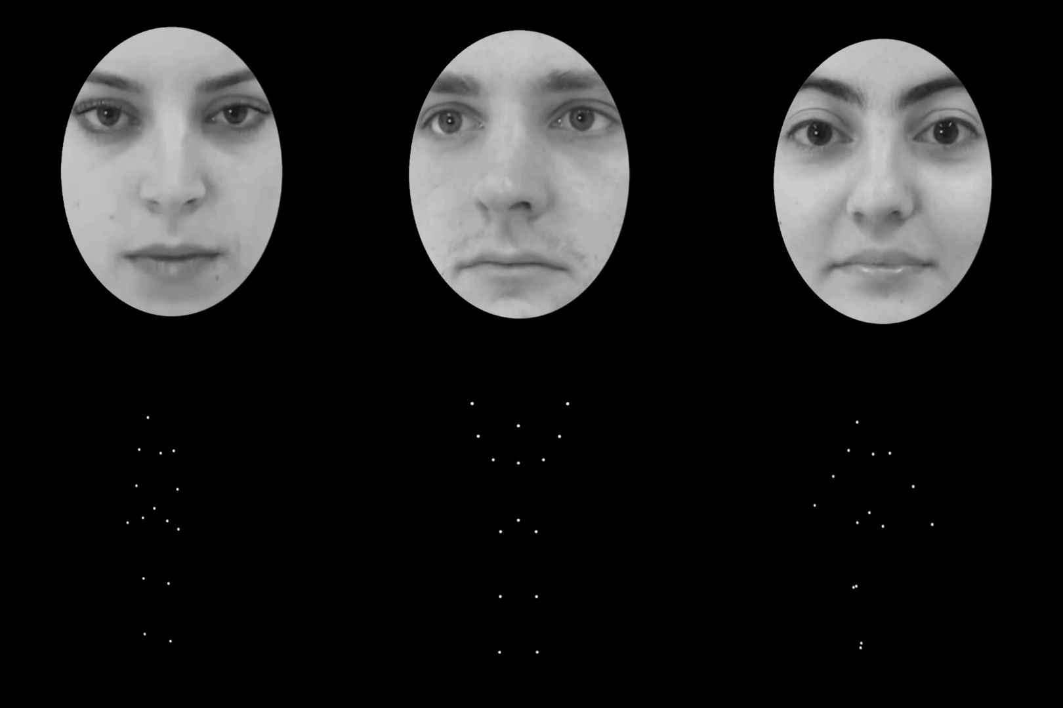

*Figure 1*.Example of the EMface AI generated facial stimuli set and EMbody AI generated 15-point body expression stimuli set.

*Procedure*

After participants were recruited, they completed the experiment online with their personal device. The experiment went through two blocks, EMface/EMbody, including 10 practice trials and 84 real trials for EMface and EM body respectively. The stimuli was presented for 0.01 seconds before the screen automatically changed to an answer screen where participants had the choice to select HAPPY, ANGRY, or NEUTRAL by mouse click. Correct answers were not sown but the participants were informed which trials were for practice and which were the real trials. The experiment automatically closed after completion and participants were not required to do anything thereafter. The resulting data was merged into a csv file and uploaded into RStudio for organization and analysis. The raw data file was coded into cohesive variables, analyzed, and interpreted as a graph in RStudio.

**Results**

The hypothesis for the analysis was 1) emotion will not be perceived equally accurately and 2) facial expressions will be perceived quicker than body expressions. To assess differences in perceived emotion based on accuracy, a 2 (block: face, body) x 3 (emotion: happy, angry, neutral) multivariate analysis of variance (MANOVA) was used. There was not a significant main effect of emotion on accuracy, *F* (2, 14) = .773, *p* = .480, n2G = .047, nor a significant main effect of block on accuracy, *F* (1, 7) = 3.006, *p* = .127, n2G = .042. The interaction effect between emotion and block was also not significant, *F* (2, 14) = 2.439, *p* = .123, n2G = .064, as listed in Figure 2. The findings did not support the hypothesis that a specific emotion would be perceived more accurately than another.

*Figure 2.* Accuracy of perceived face and body expressions organized by block.

To assess differences in perceived emotion based on reaction time, a 2 (block: face, body) x 3 (emotion: happy, angry, neutral) MANOVA was used. There was no significant main effect of emotion on reaction time, *F* (2, 14) = .116, *p* = .892, n2G = .003. However, a significant main effect of block on reaction time was shown, *F* (1, 7) - 6.151, *p* = .042, n2G = .086. The interaction effect of block on emotion was not significant, *F* (2, 14) = 2.192, *p* = .149, n2G = .026. To determine which of the two blocks had the lower reaction time the data was further aggregated determining the face block (*M* = 800.923 ms) had a lower average reaction time than the body block (*M* = 945.795 ms). The findings supported the hypothesis that face expressions were perceived quicker than body expressions as shown in Figure 3.

*Figure 3.* Reaction time of perceived face and body expressions organized by emotion. The graph details the significant main effect of block on experiment.

**Discussion**

The purpose of this study was to replicate the original study by Lott et as. And determine if their results were replicable. As significance was not being met for accuracy in this replication, the implication is that the stimuli sets may prove successfu in standardizing expression perception and reducing biases created by inequalities in other stimuli sets. While significance was also not met for reaction time where emotion on experiment and emotion on block were not significant, the significance of block on reaction time implies face expressions are quicker to be perceived than body expressions. As there were only 8 participants, the results cannot be applied to the general population or derive causation or a significant correlation. Limitations of the study are largely due to the lack of participants and inability to generalize the data to the general population. Future research on the topic should focus on perception standardization, particularly of facial expressions, to better the interplay of facial and bodily emotion expression.

**Works Cited**

Abramson, L., Petranker, R., Marom, I., & Aviezer, H. (2021). Social interaction context shapes emotion recognition through body language, not facial expressions. Emotion, 21(3), 557–568. https://doi-org.ezproxy.uta.edu/10.1037/emo0000718.supp

Ekman, P. (1992). An argument for basic emotions. *Cognition & emotion*, 6(3-4), 169-200. https://doi.org/10.1080/02699939208411068

Lott, L. L., Spengler, F. B., Stächele, T., Schiller, B., & Heinrichs, M. (2022). EMbody/EMface as a new open tool to assess emotion recognition from body and face expressions. *Scientific reports*, 12(1), 14165. https://doi.org/10.103

Nestor, M. S., Fischer, D. L., & Arnold, D. (2020). "Masking" our emotions: Botulinum toxin, facial expression, and well-being in the age of COVID-19. *Journal of cosmetic dermatology*, 19(9), 2154–2160. https://doi.org/10.1111/jocd.135698/s41598-022-17866-w

Tracy, J.L., Randles, D., Steckler, C. M. (2015). The nonverbal communication of emotions. *Current Opinion in Behavioral Sciences*, 3, 25-30. https://doi.org/10.1016/j.cobeha.2015.01.001